COMPILAR COREBOOT SEABIOS PARA X200

sudo apt-get install -y bison build-essential curl flex git gnat libncurses5-dev m4 zlib1g-dev python

git clone https://review.coreboot.org/coreboot

wget https://www.mirrorservice.org/sites/libreboot.org/release/stable/20160907/libreboot_r20160907_util.tar.xz

tar -xf libreboot_r20160907_util.tar.xz

git clone https://notabug.org/libreboot/libreboot.git

cd coreboot/
($ make help_toolchain) Por si quieres saber mas o tienes otra arquitectura.
make crossgcc-i386 CPUS=$(nproc)

make distclean
limpiamos por si hubiera configuracion anterior

make menuconfig

ROM chip size (8192 KB (8 MB)) —>
Note
Select the appropriate ROM chip size of your X200 model (4, 8, 16MB) and substract 0x3000 to get the correct size of region BIOS, or like it is called here: “Size of CBFS filesystem in ROM”.
- (0x7fd000) Size of CBFS filesystem in ROM (ejemplo para las de 8MB)
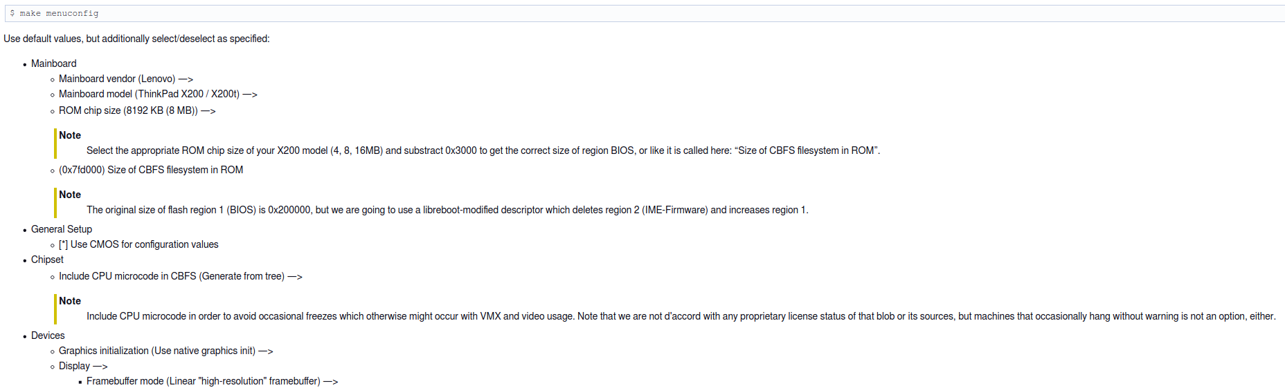

$ make

$ ./ich9gen --macaddress 00:1F:16:2E:51:2B
dd if=ich9fdgbe_8m.bin of=coreboot.rom bs=1 count=12k conv=notrunc

Cambiando valores en cmos.default
(You will be able to modify these settings with the NVRAMCUI Payload upon boot time.)

$ build/util/nvramtool/nvramtool -C build/coreboot.rom -w gfx_uma_size=256M
(importante para gráficos, juegos y video)
MOSTRANDO POSIBLES OPCIONES
$ build/util/nvramtool/nvramtool -C build/coreboot.rom -e gfx_uma_size

$ build/util/nvramtool/nvramtool -C build/coreboot.rom -w wwan=Disable
$ build/util/nvramtool/nvramtool -C build/coreboot.rom -w bluetooth=Disable
Don't forget to reset the checksum of the NVRAM Option Table to zero by unplugging the small coin battery for some seconds!!!!

EXTRAYENDO LAS REGIONES DE LA FLASH
The content of flash region 0 will not be used, instead a libreboot-modified descriptor build from scratch comes into action.
- Flash region 1 will be replaced by coreboot firmware. From the output above, the original size of that region is obvious: 0x200000.
This region will be increased by the modified descriptor, and it will be located right behind the re-located region 3.
- Flash region 2 will be deleted.
- The content of region 3 will not be used.
Instead, GbE configuration data will be build from scratch, and region 3 will be located right behind region 0.
- Flash region 4 will be deleted.

cd util/ifdtool
$ make
$ ./ifdtool -x lenovo.bin
File lenovo.bin is 8388608 bytes
Flash Region 0 (Flash Descriptor): 00000000 - 00000fff
Flash Region 1 (BIOS): 00600000 - 007fffff
Flash Region 2 (Intel ME): 00001000 - 005f5fff
Flash Region 3 (GbE): 005f6000 - 005f7fff
Flash Region 4 (Platform Data): 005f8000 - 005fffff
$ l *.bin
flashregion_0_flashdescriptor.bin flashregion_1_bios.bin flashregion_2_intel_me.bin flashregion_3_gbe.bin flashregion_4_platform_data.bin lenovo.bin

DIFERENCIAR cmos.default entre dos versiones diferentes:

./util/nvramtool/nvramtool -C rom0.rom -a > nvramrom0
./util/nvramtool/nvramtool -C rom1.rom -a > nvramrom1
$ diff -y nvramrom0 vnramrom1

COMPILAR COREBOOT SEABIOS PARA X60

$ make distclean
$ make menuconfig
Use default values, but additionally select/deselect as specified:

* Mainboard
- Mainboard vendor (Lenovo) --->
- Mainboard model (ThinkPad X60 / X60s / X60t) --->
- ROM chip size (2048 KB (2 MB)) --->
- (0x200000) Size of CBFS filesystem in ROM

* General Setup
Option backend to use (Use CMOS for configuration values)
- [*] Add a bootsplash image

* Chipset
- Include CPU microcode in CBFS (Do not include microcode updates) --->

NOTE: We prefer to avoid CPU Microcode Updates on machines that
are known to work well enough without (see libreboot’s
documentation). Otherwise select "Generate from tree".

* Devices
- Graphics initialization (Use native graphics init) --->
- Display --->
+ Framebuffer mode (Linear "high-resolution" framebuffer) --->
- [*] Add a bootsplash image

* Console
- [ ] Serial port console output

Tweak parameters `gfx_uma_size`, `wwan` and `bluetooth` in the ROM’s
`cmos.default` file:

Aquí hacemos unas mejoras, ajustes a la CMOS:
$ build/util/nvramtool/nvramtool -C build/coreboot.rom -w gfx_uma_size=64M
$ build/util/nvramtool/nvramtool -C build/coreboot.rom -w wwan=Disable
$ build/util/nvramtool/nvramtool -C build/coreboot.rom -w bluetooth=Disable

ACTUALIZAR COREBOOT:
$ sudo flashrom -p internal -w coreboot.ro
$ sudo ./nvramtool -c 0x00

